## Phase 1:

Definition of core pages/tabs:

Home Page (Dashboard):

* Displays ‘visible’ sticky notes
* Option to add, delete and modify notes

Settings tab:

* Change themes, vision assistance

Timer page:

* A notebook with writing on it

  Description automatically generated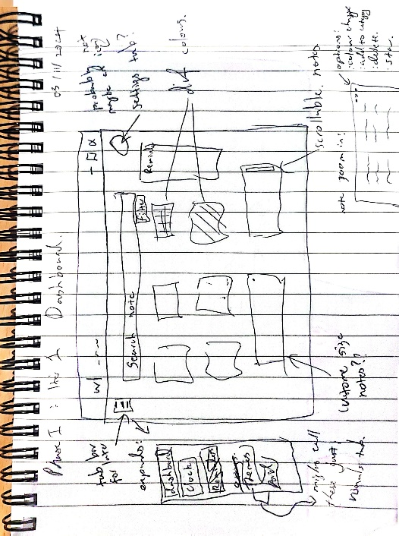Clock(s), timer

Doodles below: (05/11)